Communication Management Plan Version 1.0

Group – 9

Team Members:
- Himaja Parachuri
- Raghavendra Reddy
- Venkata Gopi Siva Sai Nallapati
- Sai kumar Mylavarapu
- NagaTeja Neerukonda

Date: 5/29/2021

Project Name: LI-ON Power Pack

- Stakeholder communications requirements:
A project status report is emailed to all stakeholders. Himaja parachuri is responsible for sending this email as per the communications summary listed below.

- Communications summary:

Stakeholders | Communications Name | Delivery Method/Format | Producer | Due/Frequency
Project steering committee | Weekly status report | Hard copy and short meeting | Sai Nallapati  /Saikumar Mylavarapu | Monday,Tuesday 10 AM
Sponsor and champion | Monthly status report | Hard copy and short meeting | NagaTeja Neerukonda | First Wednesday every Month at 10 AM
Affected employees | Project announcement | Memo, e-mail, intranet site, and announcement at department meetings | Raghavendra Reddy | Due 5th June,2021
Project team | Weekly status report | Short meeting | Himaja Parachuri | Thursday 10 AM

- Comments/Guidelines:

• If a statutory holiday falls on a business day, meetings will be held the following business day.
• If the meeting is canceled owing to issues, all stakeholders must get a full report on the topics to be discussed during the meeting.
• Any delay in filing a report must be communicated at least two hours ahead of time.
• Following each meeting, all stakeholders should be given a report on what was discussed and the meeting's outcome.

- Escalation procedures for resolving issues:

To report any development issues in the project, the below escalation matrix is used:

Sai Nallapati→ Sai Kumar → Raghavendra Reddy → Naga Teja → Himaja

To report any issues related to scope, deadlines, etc. The escalation matrix to be followed is:
Team → Himaja → Stakeholders

- Revision procedures for this document:

In case there are any changes to this document, the steps mentioned should be followed in order:
- Team makes the required changes to the document and assigns a new version number to it.
- Himaja reviews the document and sends it to the stakeholders for signoff.
- Once all the signoffs have been received, they are documented and saved for future reference.
- Himaja sends an email to all stakeholders with the amended document.

Flowchart for the revision for the project:

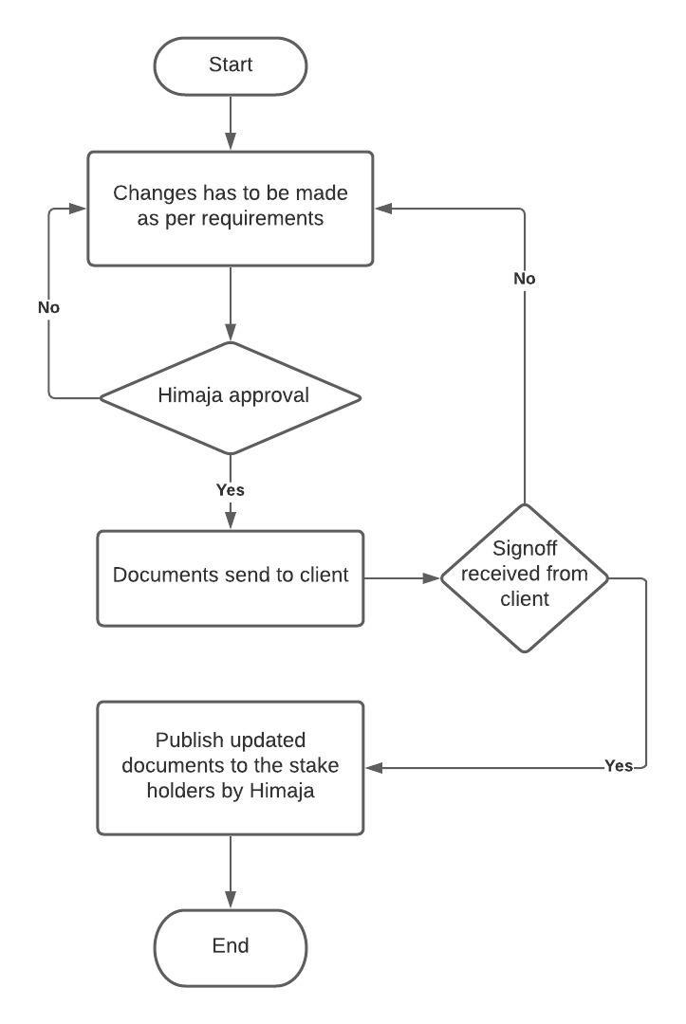

- Glossary of common terminology:

Champion:
The team member in charge of a project management project is known as a project champion. This is the individual who ensures that everyone is on board and that the project is completed effectively and on time.

Deadline:
A deadline is a target date by which you want a task to be finished. Project provides an indicator if the due date has passed and the work has not been finished.
Escalation:
The escalation process is generally a formal process to highlight the problem in project to a higher authority to resolve an issue.

Flow Chart:
A diagram depicting the order in which people or things in a complicated system or activity move or act. it represents a process or workflow.

Project progress report:
a document that explains in detail how far we have gone towards the completion of a project. It outlines the activities you've carried out, the tasks you've completed, and the milestones we have reached in project plan.

Scope:
A project scope is a complete summary of all parts of a project, including all relevant activities, resources, schedules, and deliverables, as well as the project's limits.

Sponsor:
The project sponsor is a person or organization that owns the project and provides resources and support to ensure its success.

Project Steering committee:
The role of the Steering Committee is to give guidance, ensure the delivery of project deliverables, and assure the attainment of project objectives.

